|  |
| --- |
| **Google Analytics for [project] Admin Portal** |
| Evaluation User Acceptance Test eUAT |
|  |
|  |
| *Making sense of Google Analytics data can be a daunting task. The goal of this report is to present metrics in a meaningful and engaging way. The Highlights section is a one page summary of key findings. The body of the report is designed around a series of high level questions about the [project] Admin Portal. The conclusion focuses on priority next steps, as well as identifying key terms and resources. The information collected for this document is specific to the administrative portal and does not assume any data for DDS, search queries, Zimbra, or Outlook.* |
|  |
| **Desarae Veit**  Senior UI/UX Designer, [TEAM]  Email:email, Phone: phone,  Address: add |
|  |
|  |



Portal. [project].com Report

(1 November – 10 November 2014)

## Browser Report

* **The most used browser traffic to Portal. [project]2.com is 31.20% IE 8.** The most used supported browsers in order of use are IE 8, IE 10, IE 11, Chrome, IE 9, and Firefox. Minimal mobile traffic has been tracked, but some users have visited the portal on mobile phones and tablets. Based on the number of page views, it would appear that the mobile traffic is minimal at this time and not the primary source for testing since the page views are also minimal with a high bounce rate.
* **[number] unique users have visited the site from outside of the USA, [number] of those users are testing the portal on unsupported browsers.** The most used unsupported browser is IE 7, followed by older versions Firefox, Chrome, and IE with Chrome Frame extensions.
* **[number] people from England, Scotland, and Wales have visited the site.** The site has over **[number]** page views, only **[number]** % of page views are from help content.
* **The average user spent [number] minutes on the site.** Users spent less than **[number]** minutes per page. Per session users either visited only 1 page or more than **[number]** pages on the site.
* **The 11 most popular pages include Login, Logout, Home, Manage Users, Forgot Password, Help, Security Questions, Create New User, Edit User, Admin Help, and Directory.** More than **[number]** % of site traffic is spent on the Manage User screen. The Manage User page is the 4th most visited page on the site. Once on the home page, visitors most frequently navigated to Login (**[number]** %), Security Questions (**[number]** %), or Account Profile (**[number]** %), Help (**[number]** %).
* **The Help Screen has over [number] page views, but it is only [number] % of site traffic. The most selected help documentation is the Admin Help. [number]** % of users searching for help content visit the main help screen, followed by **[number]** % to the Admin Help. The average time on help documentation is under **[number]** minutes, except the mobile help documentation which is **[number]** minutes.
* **Additional setup needed for search analytics.**
* **Additional setup needed for user feedback.**
* **Additional time needed for issue indication.**
* **IP traffic filtering recommended for analytics.**

# Infograph of Statistics… https://encrypted-tbn3.gstatic.com/images?q=tbn:ANd9GcS2D1inUqt9Z_SiMsMhM9njq9_UapW8Q7ph0bFr8409yf3c928PJw

# Reports…

* **Audience Overview**…………………………..……Pg 4-6
* How many people visited the site?...........Pg 7
* How engaged were the visitors?...............Pg 8
* **Content Efficiency Overview**…………..……..Pg 9-10
* Which pages did they visit the most?........Pg 11-12
* What are the users looking for? ………………Pg 12-17
* Where do visits begin?...............................Pg 17-18
* Where are users going from the home page?.. Pg18
* **Search**………………………………………………………Pg18-19
* What are the users looking for? ………………Pg18-19
* **Browser Overview**…………………………………..Pg 19-25
* **Issue Indication**………………………….…………..Pg 25-26

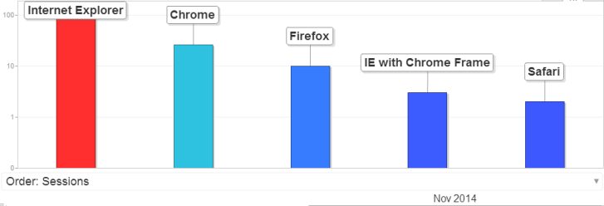**[screenshot]**

|  |
| --- |
| If you have any questions about the reports in this document, get in touch by emailing  [[email]](mailto:desarae.veit@gdit.com) |

# Audience Overview

See also ***Analytics All Web Site Data Pages 20141101-20141110.xlsx*** or ***Analytics All Web Site Data Pages 20141101-20141110.pdf*** or ***Previous Page Path 20141101-20141110 (1).pdf***

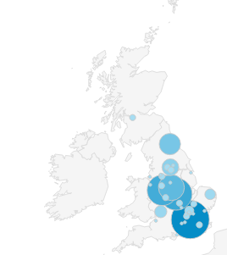

Figure 1 Page views

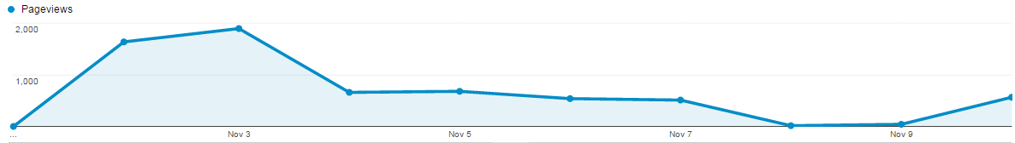   
 Spike in traffic from first official day of eUAT

Figure 2 Session Duration

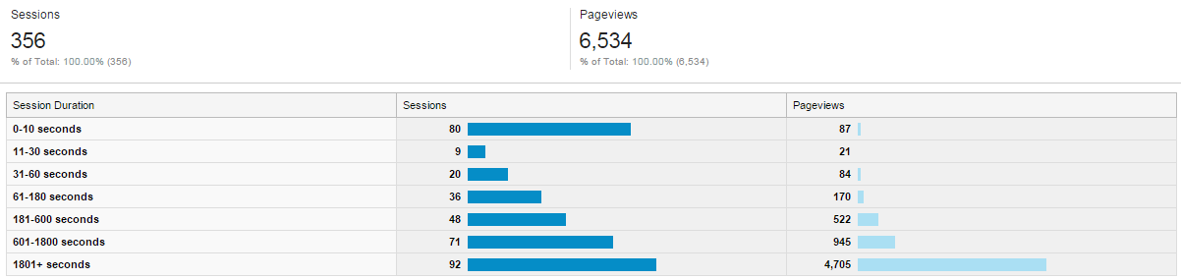

Figure 3 Page Depth

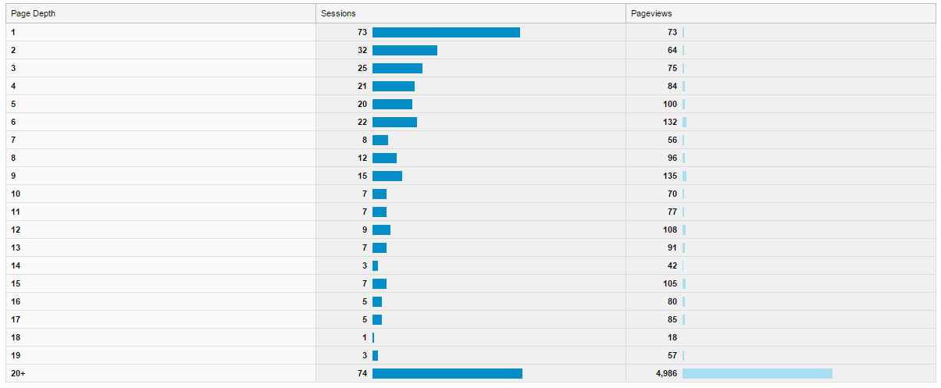

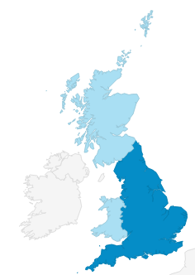

Figure 4 Page views

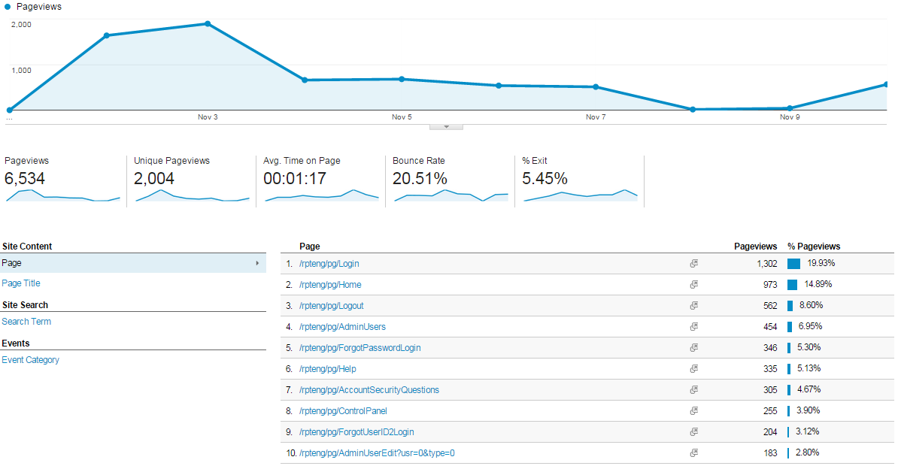

# Content Efficiency Overview

Figure 5Pages visited after Admin User (Manage Users) excluding Home

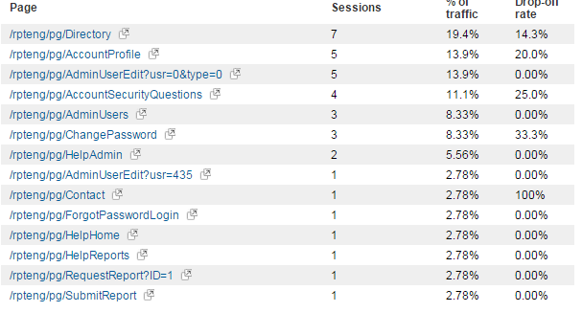

Figure 6 Where users go after leaving the Manage Users Screen followed by Returning to the Home Page

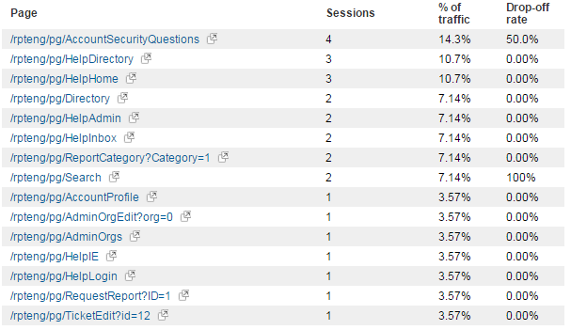

Figure 7Help Content Page view pie chart

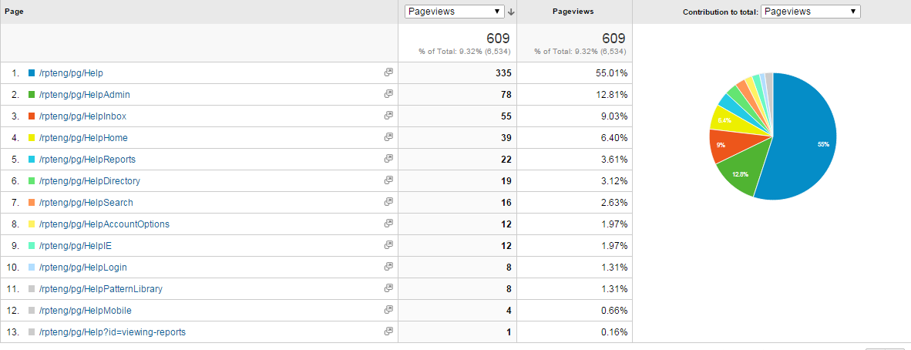

Figure 8Average time on help pages

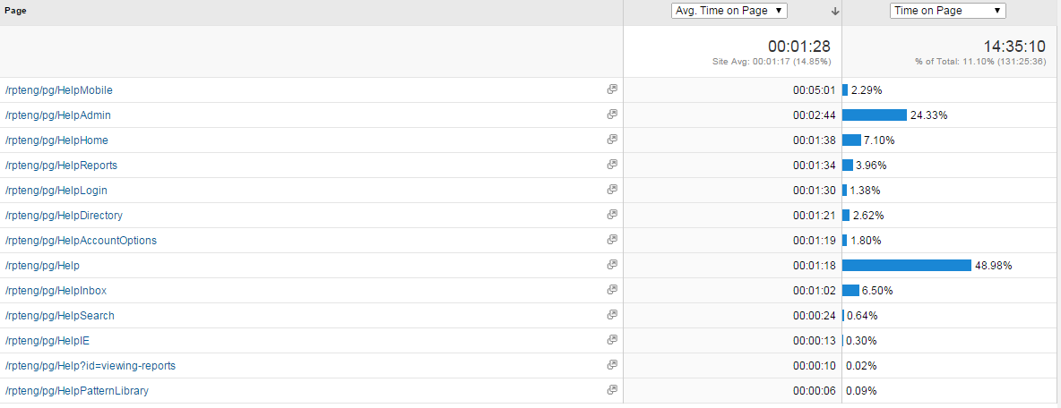

Figure 9Total percent of views compared to total site views for Help Content

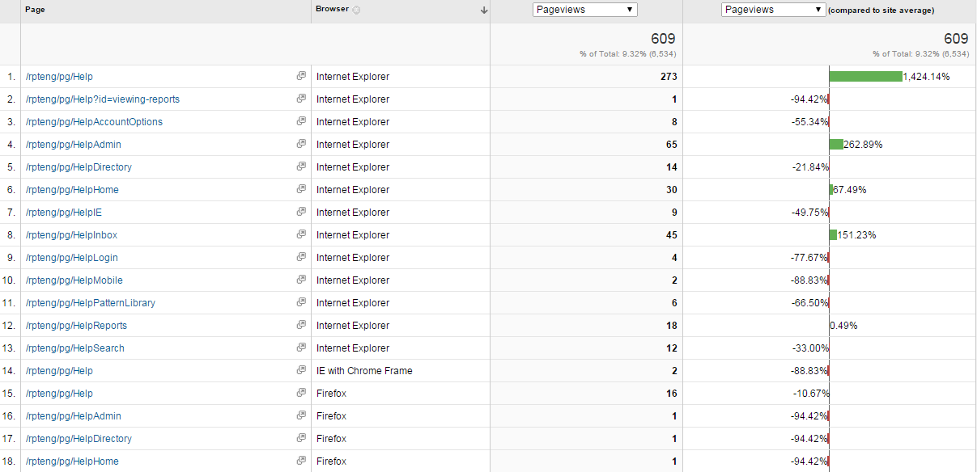

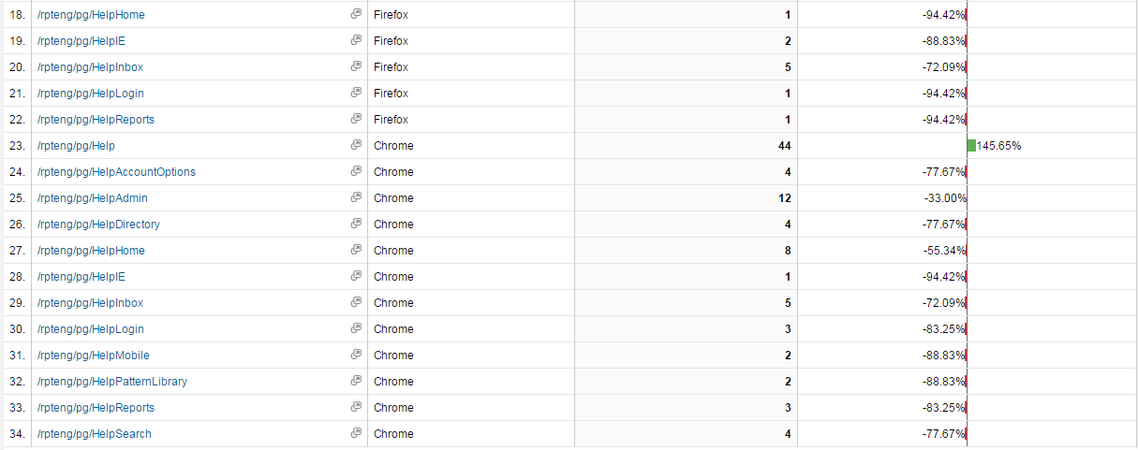

|  |  |
| --- | --- |
| **The most visited help documentation in descending order:**   1. Help (Main Help Page) /rpteng/pg/Help 2. /rpteng/pg/HelpAdmin 3. /rpteng/pg/HelpInbox 4. /rpteng/pg/HelpHome 5. /rpteng/pg/HelpDirectory 6. /rpteng/pg/HelpReports 7. /rpteng/pg/HelpSearch 8. /rpteng/pg/HelpAccountOptions 9. /rpteng/pg/HelpIE 10. /rpteng/pg/HelpLogin 11. /rpteng/pg/HelpMobile 12. /rpteng/pg/HelpPatternLibrary 13. /rpteng/pg/Help?id=viewing-reports | **Highest Page Views compared to site average in descending order:**   1. Login 2. Home 3. Help 4. Manage Users 5. Account Security Questions 6. Create New User 7. Logout 8. Edit User 9. Admin Help 10. Directory 11. Inbox Help 12. Reports 13. Help Home 14. Account Profile 15. Search 16. Edit Ticket 17. Directory Help 18. Manage Organisations 19. Reports Help 20. Search Help 21. Forgot Password 22. Change Password 23. Create new Organisation 24. IE Help |

Figure 10Help documentation page views and referral pages

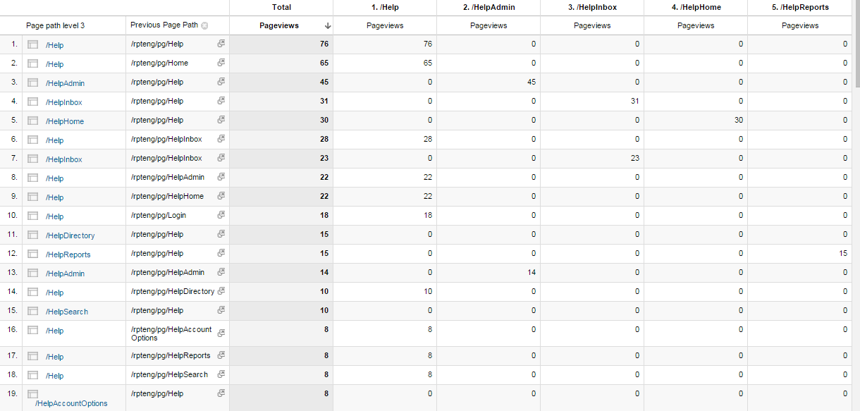

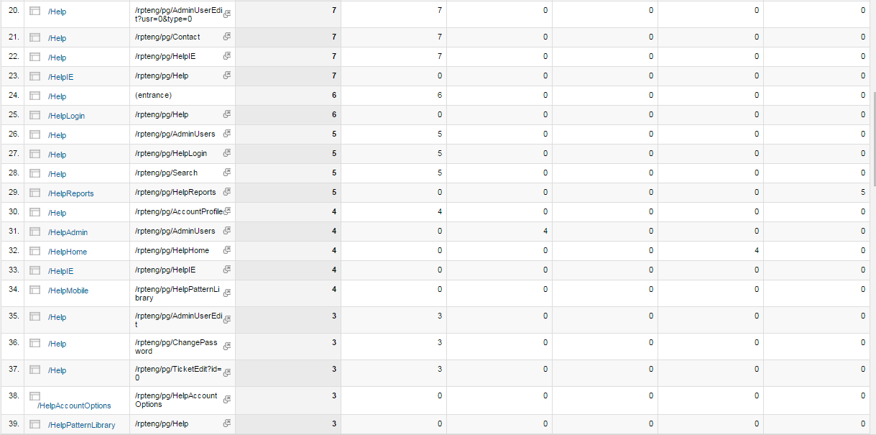

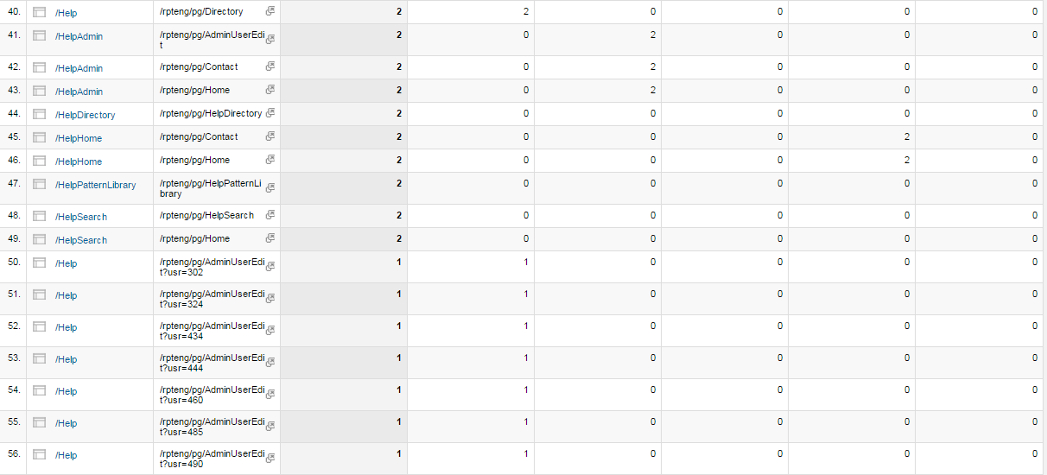

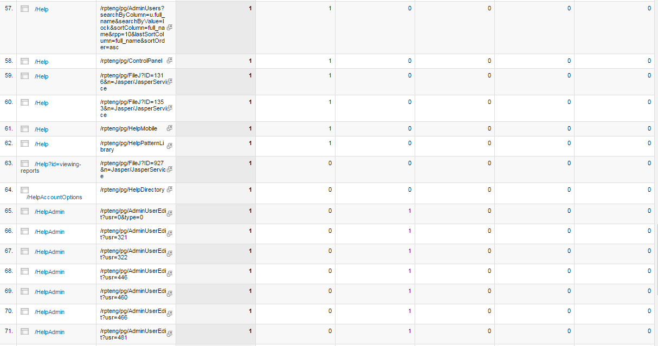

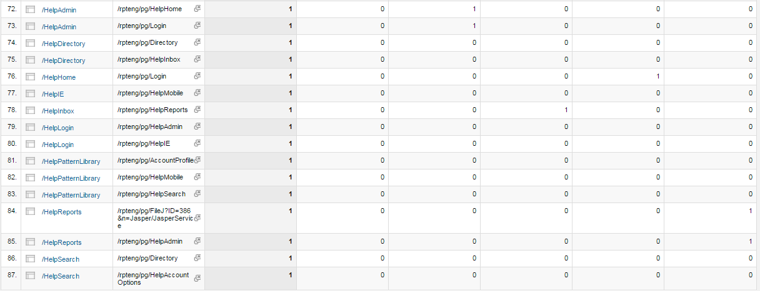

Figure 11 Visitor Flow

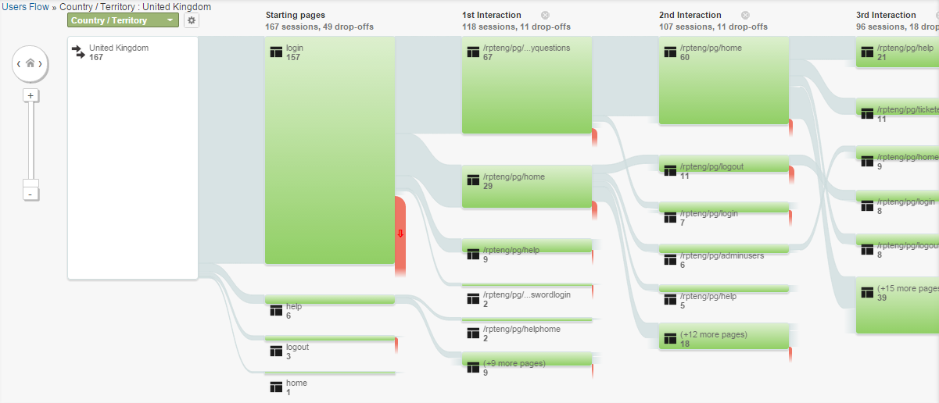

This report will require evaluating Zimbra, DDS, user management search, organisation management search, and data dumps from the admin portal search features.

|  |
| --- |
| **“***Site search analytics are an extremely interesting and often overlooked way to see exactly what people are looking for on your site. They might seem like a no-brainer but I’d say about 90% of the analytics installs I’ve looked at didn’t have this set up – and it only takes about 30 seconds!*  *Search analytics are especially useful since they can reveal what users might be after that you haven’t accommodated for in your navigation or on your homepage. It might also bring to light that your visitors are using different words or terms than those you might expect, prompting changes to your navigation.*  *This is usually one of the first things I look at when doing a site audit, as it’s a very quick way to identify deficiencies in the site navigation or gaps in content.*.**”** *–* SpeckyBoy.com |

Figure 12Example of Word Cloud of Internal Site Search Terms



[A quick note on creating word clouds… These word clouds were made using the free site [www.Wordle.net](http://www.Wordle.net). To create word clouds in Wordle, follow these three steps. First, export your terms from Google Analytics to excel. Next combine the term or phrase with the number of visits, separated by a colon, using the concatenate function (=CONCATENATE(A2, “:”,B2). Finally, upload the new string to Wordle.net using the Advanced feature. Once you have created your word cloud you can change the layout, font, and colors.]

## Browser Report

View Report Online:Go to Custom Reports > Browser Report

This report defines how different browsers are performing for [project]’s Admin Portal. The report allows GDIT to track the number of users with unsupported browsers, browser versions, modes, and extensions. Browser issues may often be tracked by reviewing extremely high bounce rates against low bounce rates for other browsers.

Users have been segmented by browser type, version, and all USA users have been excluded from the report.

### Questions and Evaluation

1. How many users are using supported browser versions?
2. What browsers should we support after the eUAT?
3. What percentages of users are using unsupported formats, extensions, or browser modes?

### Results:

|  |  |
| --- | --- |
| Figure 13 - Browser Popularity by Session | As you can see by the chart in figure 1, the most popular browser for users in the UK is IE, followed by Chrome, Firefox, IE with a Chrome Frame (not supported), and Safari. No other browsers are listed in use at this time. |

The chart in figure 2 lists the total number of sessions[1] for each browser based on version number. Total number of sessions is 323 with 167 of those sessions not originating from the United States. Total number of new users is 124.

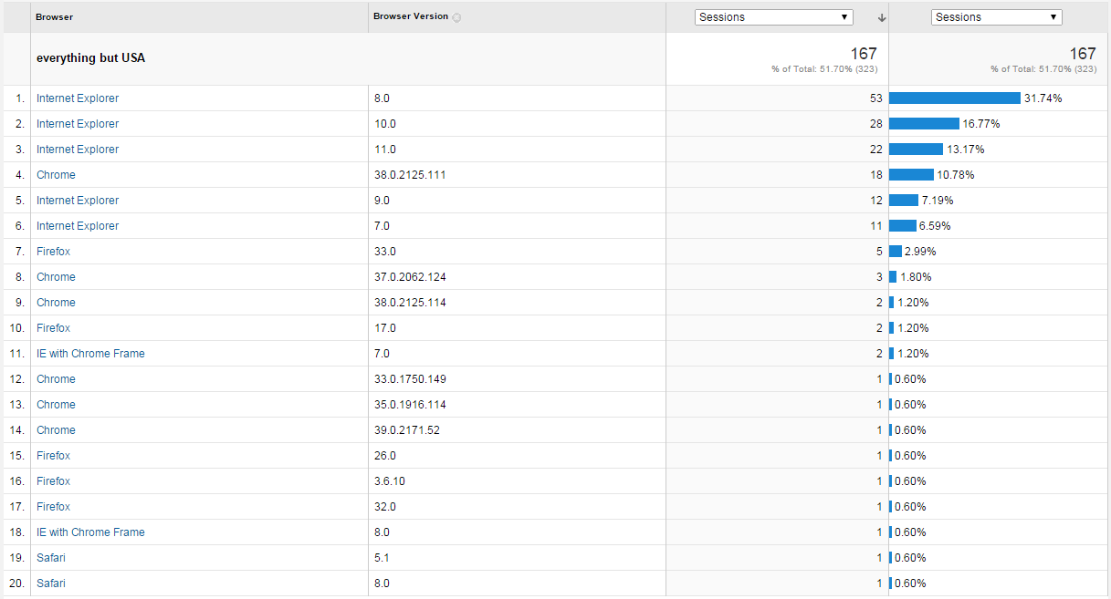

Figure 14 - Percentage of Sessions per Browser (excluding USA)

The results are as follows in order of session (unsupported versions are annotated with a (**\***) red asterisk:

|  |  |  |  |
| --- | --- | --- | --- |
| Browser & Version | Notes | Users | Sessions |
| IE 8 |  | 39 | 53 sessions (31.74%) |
| IE 10.0 |  | 17 | 28 sessions (16.77%) |
| IE 11.0 |  | 16 | 22 sessions (13.17%) |
| Chrome 38.0.2125.111 |  | 15 | 18 sessions (10.78%) |
| IE 9.0 |  | 7 | 12 sessions (7.19%) |
| IE 7.0* |  | 10 | 11 sessions (6.59%) |
| Firefox 33.0* | This is not the latest version of Firefox | 6 | 5 sessions (2.99%) |
| Chrome 37.0.2062.124* | This is not the latest version of Chrome | 1 | 3 sessions (1.80%) |
| Chrome 38.0.2125.114 |  | 1 | 2 sessions (1.20%) |
| Firefox 17.0* | This is an extremely old version of Firefox | 1 | 2 sessions (1.20%) |
| IE with Chrome Frame* 7.0 | This is an unsupported version of IE with an unstable extension for viewing | 2 | 2 sessions – (1.20%) |
| Chrome 33.0.1750.149* | This is an old version of Chrome | 1 | 1 session (.60%) |
| Chrome 35.0.1916.114* | This is an old version of Chrome | 1 | 1 session (.60%) |
| Chrome 39.0.2171.52* | This is an old version of Chrome | 1 | 1 session (.60%) |
| Firefox 26.0* | This is an extremely old version of Firefox | 1 | 1 session (.60%) |
| Firefox 3.6.10* | This is an extremely old version of Firefox | 1 | 1 session (.60%) |
| Firefox 32.0 * | This is an extremely old version of Firefox | 1 | 1 session (.60%) |
| IE with Chrome Frame 8.0* | This browser is supported, but the Chrome Frame is unstable and therefore not supported for the eUAT | 1 | 1 session (.60%) |
| Safari* 5.1 | Safari is not supported for the eUAT | 1 | 1 session (.60%) |
| Safari* 8.0 | Safari is not supported for the eUAT | 1 | 1 session (.60%) |

***32 Total Unsupported Sessions***

TOTAL Number of sessions using unsupported browsers or extensions:

|  |  |
| --- | --- |
| ***Sessions (as of Nov 1-Nov 10)***  IE 7 – 11  Firefox 33 – 5  Chrome 37 – 3  Firefox 17 – 2  IE 7 with a Chrome Frame – 2  Chrome 33 – 1  Chrome 35 – 1  Chrome 39 – 1  Firefox 26 – 1  Firefox 3.6.10 – 1  Firefox 32 – 1  IE 8 with Chrome Frame – 1  Safari – 2 | ***32 Total Unsupported Users (as of Nov 1-Nov 10)***  IE 7 – 10  Firefox 33 – 6  Chrome 37 – 3  Firefox 17 – 2  IE 7 with a Chrome Frame – 2  Chrome 33 – 1  Chrome 35 – 1  Chrome 39 – 1  Firefox 26 – 1  Firefox 3.6.10 – 1  Firefox 32 – 1  IE 8 with Chrome Frame – 1  Safari – 2 |

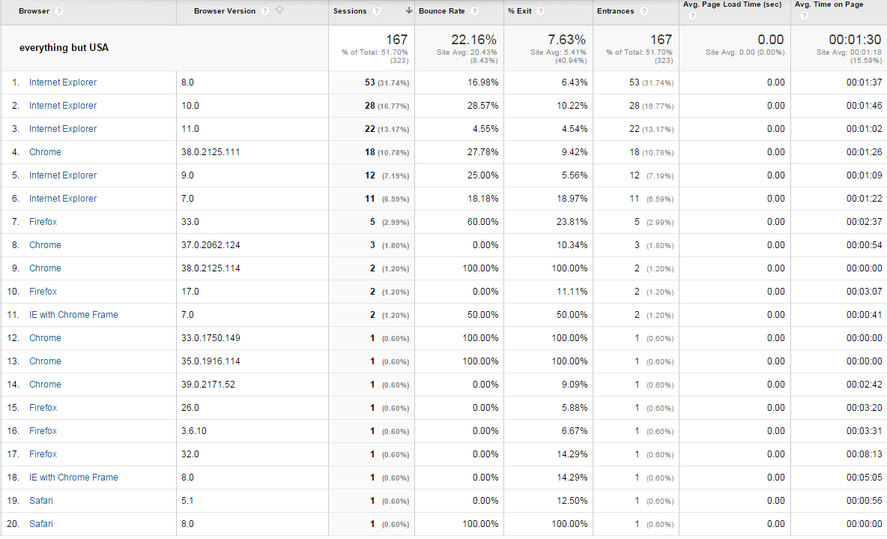

Figure 15 - Site Usage Statistics by Browser based on Sessions

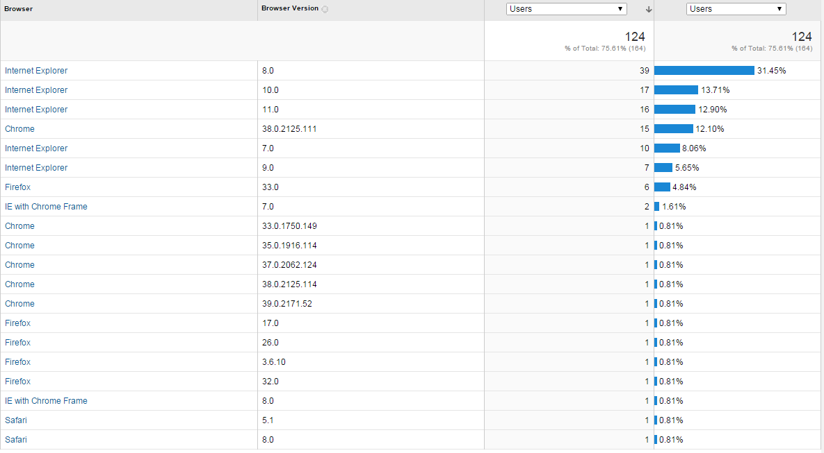

Figure 16 - Site Usage Statistics by Browser based on Users

### Recommendations:

* Chrome - Dev Channel 40.0.2209.2 (Dev beta releases ***not*** supported)
* Chrome – Beta Channel 39.0.2171.54 (Beta releases ***not*** supported)
* Chrome – Stable channel 38.0.2125.119 platform version 6158.76.0 (the latest version of chrome ***is*** supported)
* Firefox – Version 33.1 or the latest version ***is*** supported
* IE 11 ***is*** supported
* IE 10 ***is*** supported
* IE 9 ***is*** supported
* IE 8 ***is*** supported
* IE 7 ***is not*** supported
* IE 6 ***is not*** supported
* IE 5 ***is not*** supported
* IE in standards mode only ***is*** supported use of compatibility mode, edge mode, mobile view extensions, chrome view extensions, or other extensions that are intended to modify browser views are ***not*** supported.
* Opera Next – ***Not*** supported in any version
* Safari – ***Not*** supported in any version
* Opera – ***Not*** supported in any version
* Netscape – ***Not*** supported in any version
* Any other browser version or extension not listed here ***is not*** supported.

## Issue Indication

**While designing the site or launching new features to develop, the UX team implements a measurement plan. A measurement plan requires daily or weekly reports to monitor the site’s ability to meet the stated goals, and track or diagnose specific issues.**

### Questions and Measurement

1. **Question:** What content are users having trouble finding or navigating to?   
   **Measurement:** Pages that do not show up in analytics, have drop-off, have little or no analytics, content often reviewed in help documentation, or search terms with high results.
2. **Questions:** Which pages are receiving the most error messages?  
   **Measurement:** Error messages
3. **Problem:** Traffic issues – users may have a difficult time navigating back to the administrative portal from Zimbra or Outlook.  
   **Measurement:** Traffic sources – Determine how many users are directly navigating to the site, book marks, or other sources.
4. **Problem:** Determine if a page or element is not loading properly (also track by browser/version)  
   **Measurement:** Event Pages – The event pages report lists all the pages with tracked events.
5. **Problems:** Do any pages have content or visual-design issues? Determine if any wording may not effectively communicate the action process. Determine if any imagery, typography, colors, or layout are distracting from action items.  
   **Measurement:** In-Page Analytics indicates what links users select. A/B testing may further improve the process if additional designs are needed. Forms may be tracked with success or error messages. ***Clicktale or CrazyEgg have more advanced in-page analytics.***
6. **Problems:** Navigational issues – Determine if specific links/buttons are not being clicked.  
   **Measurement:** Pages report (filtered by page URI and selecting Navigation summary) details pages people came from before visiting the page of interest and where they went after visiting that page.

# Additional Considerations

* **Filter internal traffic by IP**
* **Consider additional reporting tools like:**
  + **Adobe Report builder**
  + **Adobe Discover**
  + **User Feedback Survey**
  + **Mix Panel**
  + **Optimizely**
  + **Heat Map or Mouse Flow Analytics**
* **What are users doing on the website?** – User flows show how visitors consume content, how they get to specific pages, and which pages are hard to find.
  + - Event tracking captures user actions within web pages such as downloading a document, interacting with a calculator, watching a video, filling out form fields, etc.
    - In-page analytics will show where users are clicking from one page to the next. In-page analytics can help define if users are clicking more often on data that wasn’t originally valued as a high priority.
    - User scroll depth – this defines how far down a user is scrolling before leaving a page. This may help define why users are having a hard time finding certain content and mean that certain data needs to be moved up.
    - Visitor User Flow – gives an overview on the paths users are taking, their bounce rate per page, and shows which pages may need more focus to decrease bounce rates (this may be due to poorly named content or that users are not getting the kind of content they are expecting from that section).
    - Heat map tools or mouse flow tools – watch how users flow about a page and what content is overlooked. (not currently in use)
    - Quickly prove/disprove causation/correlation theories
* **What are popular platforms?** – Analytics allow us to analyze which browsers are used, how popular they are, which versions, computer models, internet connections, page speeds, and regions the users are viewing the site from.
* **Personas and Audience Overview –** ie. who is the user? Demographics allows for generalized sets of users. In public websites this often means that data can generally include gender, age, and sometimes even nationality. This is harder to do on business platforms using Google Analytics because users would need to have a Google profile and be signed in to retrieve this data. In [project], users do however create profiles, so in future we could include additional questions in the user profile including gender and birthday to include a general view of this data.
* **How is the website performing?** – Performance data includes page load time, errors, and bounce rates.
* **Issue Identification**: Find problems to be solved.
* **Strategy Guidance:** Justifying projects, validating personas, informing customer journeys maps, and collecting background information necessary for design planning
* **Health Monitoring:** Ongoing measurement plan and Key Performance Indicators (KPIs) that indicate if there are UX issues
* **Project Metrics:** Determining project-specific metrics that can be measured before and after implementation to ensure satisfaction with your deliverables.
* **Experimentation:** Running A/B and multivariate tests to improve results via different design and content variations.

# Resources

## Glossary

|  |  |
| --- | --- |
| Term / Abbreviation | What it stands for |
| A/B Testing |  |
| Active Session | The period during which a User is logged on to the Services, determined from the moment when the User’s credentials are authenticated by the Services until the moment when that User ceases to use the Services by either logging out or, after an agreed period of inactivity, the User is automatically logged out for security reasons. |
| Administrator | A User who has access to special tools to administer User accounts and other aspects of the Services received by their Organisation or group of Organisations. |
| Anonymous User | A User who has not authenticated themselves to the Services using authentication credentials such as to access the directory or training/guidance material from a secure network. |
| Archiving Service | A service to enable each User to archive their own email and/or calendar data. |
| Automatic Password Reset | Functionality which enables a User to reset their password through the supply of several factors known only to that User. |
| Average Visit Duration |  |
| Average Time on Page | The average amount of time users spent viewing a specified page or screen, or set of pages or screens. |
| Bounce Rate | Bounce Rate is the percentage of single-page visits (i.e. visits in which the person left your site from the entrance page without interacting with the page). |
| Browser | The browsers used by visitors to your website. |
| Browser Version | The browser versions used by visitors to your website. |
| Classification propensity | Used to predict an event or the likelihood of an occurrence of an event when there are two possible outcomes for the event, known as churn prediction |
| Clustering | Used to detect associations between discrete events, products, or attributes. |
| Effort of Report Priority | Is this a tiny content tweak that can be made in the CMS, or the introduction of a whole new site feature that needs building from scratch? (quick wins vs. long term redesign considerations) |
| Entrances | Entrances are the number of times visitors entered your site through a specified page or set of pages. |
| Estimation regression | Similar to classification models but used to estimate a continuous value vs. binary outcome. Known as a cross-sell model. |
| Exit rate |  |
| Heatmap tools |  |
| Historical trends | Google Analytics has the ability to control date ranges and benchmarking of data. This allows site tracking of data over time as well as behaviors, add annotations, and include internal factors that may cause fluctuations. |
| Impact of Report Priority | Is it going to marginally improve content, or will it fix a huge usability issue that is costing us conversions? |
| In-page analytics |  |
| Key Performance Indicator (KPI) | Evaluate the success of goals, metrics, or engagements based on quantitative or qualitative results. KPIs must be rooted in quantifiable data. |
| Navigation Summary |  |
| Page value |  |
| % new visits |  |
| Page views/ Unique page views |  |
| Page visits |  |
| Segments |  |
| Sessions | Total number of Sessions within the date range. A session is the period time a user is actively engaged with your website, app, etc. All usage data (Screen Views, Events, Ecommerce, etc.) is associated with a session. |
| Sequence | Used to detect associations over time. Known as path analysis. |
| Tag managers |  |
| Unique Visitors |  |
| User Interface |  |
| User Centered Design |  |
| User Experience |  |
| Visits/Sessions |  |

# **Bibliography**

ANALYTICS, P. (n.d.). *Engagement events are individual activities performed using specific social networks, sites, or applications. One tweet is an engagement event, for example as is posting one comment, or voting one digg. PostRank tracks these events and gives analysts the* . Retrieved from POSTRANK ANALYTICS: https://analytics.postrank.com/

Beasley, M. (n.d.). *Practical Web Analytics for the User Experience.*

Cardello, J. (n.d.). *Analytics UX*. Retrieved from Nielsen Norman Group: http://www.nngroup.com/articles/analytics-user-experience/

COMPETE.COM. (n.d.). *Compete.com is a simple tool for gauging a website’s traffic versus that of its competitors. Compete also allows members to track that data over time to make calculated decisions based on their competitor’s strategy.* Retrieved from COMPETE.COM: COMPETE.COM

Eyal, N. (n.d.). *Complete Guide to Web Analytics and Measurement*. Retrieved from UX Booth: http://www.uxbooth.com/articles/complete-beginners-guide-to-web-analytics-and-measurement/#what

Google. (n.d.). Retrieved from Chrome Releases: http://googlechromereleases.blogspot.com/

Google. (n.d.). *Analytics Academy*. Retrieved from https://analyticsacademy.withgoogle.com/explorer

Google. (n.d.). *Google Analytics*. Retrieved from http://google.com/analytics

Google. (n.d.). *Google Optimizer*. Retrieved from http://www.google.com/websiteoptimizer/b/index.html

Google. (n.d.). *Google Webmaster Tools*. Retrieved from http://google.com/webmastertools

*Google UX tips*. (n.d.). Retrieved from Speckyboy: http://speckyboy.com/2014/07/24/google-analytics-tips-ux/

ICEROCKET.COM. (n.d.). *Icerocket is a simple off–site analytics tool that gives interested parties a glimpse into the latest chatter going on around their website.* Retrieved from ICEROCKET.COM: ICEROCKET.COM

Insights, K. (n.d.). *KISS Insights is a tool that allows designers to place a small survey bar across the bottom of their websites. Curious visitors can take a peek and are then presented with a simple survey in which they can evaluate the experience design of your website.* Retrieved from Kiss Insights: http://www.kissinsights.com/

Kaushik, A. (n.d.). *Author, Digital Marketing Evangelist - Google, Co-founder - Market Motive.* Retrieved from Kaushik: http://www.kaushik.net/avinash/

Kaushik, A. (n.d.). *Web Analytics 2.0.*

Optimizely. (n.d.). Retrieved from Optimizely: https://www.optimizely.com/

Panel, M. (n.d.). Retrieved from Mix Panel: http://mixpanel.com

PLANNER, Q. (n.d.). *Quantcast Planner lets you search, rank, and sort millions of Web properties in real-time according to the criteria that matter to you, including audience age, gender, ethnicity, income, education, and geographic location as well as constraints such as pr*. Retrieved from QUANTCAST PLANNER: http://www.quantcast.com/info/planner-overview

Siu, E. (n.d.). *Time Saving Google Analytics Custom Reports*. Retrieved from Search Engine Watch: http://searchenginewatch.com/article/2175001/7-Time-Saving-Google-Analytics-Custom-Reports

Tale, C. (n.d.). *ClickTale captures every mouse move, click, scroll, and keystroke that a visitor makes inside a webpage, and then sends this information back to the ClickTale servers in a highly compressed package. In addition, ClickTale takes a snapshot of the webpage a*. Retrieved from ClickTale: http://www.clicktale.com/

**Detailed Design Documentation**: [project]-UX Considerations 0.3.docx

**Branding**: [PROJECT] Brand Guidelines_2010 v2.docx

**User Roles**: [project]-roles_2014-8-21.docx

**Requirements**: [project] 2 User Evaluation User Test Requirements V1 5a.docx

1. Total number of Sessions within the date range. A session is the period time a user is actively engaged with your website, app, etc. All usage data (Screen Views, Events, Ecommerce, etc.) is associated with a session.